Using Git …

What: Every Tuesday In November at Noon in Inst 120 (starts Nov 5) ->

We will review a series of videos on how to use a popular source control tool

called GIT. These meetings will review a series of Linked in learning videos.

All are welcome and bring a computer.

How to get extra credit:

1. Attend the Git event

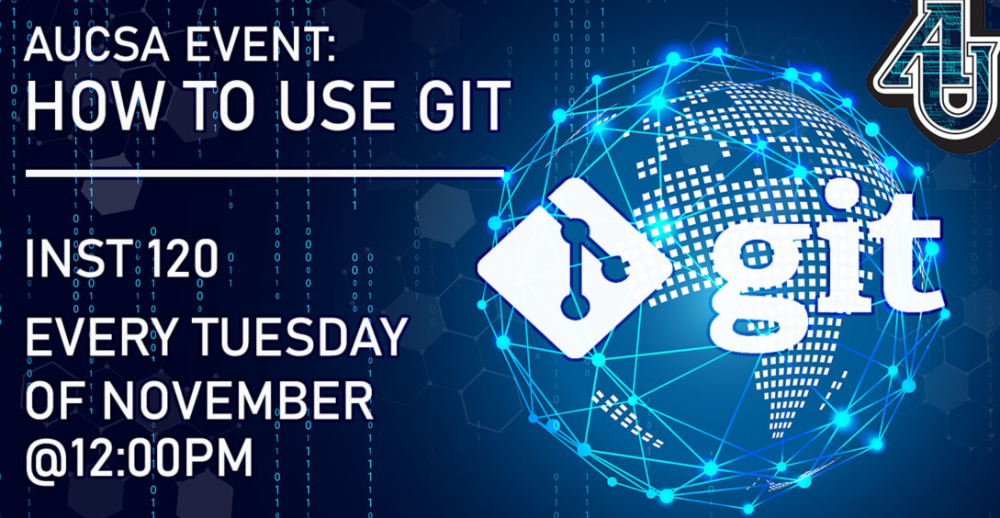

1. Upload a word document with annotated screen shots that shows you completing at least 3 exercises. (By annotated I mean, show a screen shot and provide 1 or 2 sentences that describes it.)